Case study 4.3: Hands-off FCL using autoISF 3.0 on Xmas V.2.0

Adult user on AAPS using Lyumjev / AccuChek Combo/ 2x G6 overlapping
Hands-off FCL utilization on the Christmas holidays. No user interference (no boli, no carb inputs, no setting Eating Soon or any other inputs (%profile, TT…)).
Features from initial FCL set-up that the loop automatically did use:
- Set profile, including odd profile target ca 3am-10am (SMBs default* shut-off )
- Set autoISF parameters (24/7 adaptation of ISF; bgAccel_ISF_weight = 0.24; pp_ISF_weight = 0.03 etc.)(iobTH_percent=60)
- Automation that sets TT=74 mg/dl for 26m if delta>10
- *Automation for temp. SMBs (if bg>160; iob<3.5) during nighttime
- Activity monitor 24/7 on (with scale factors 1.2 activity and 0.3 inactivity)
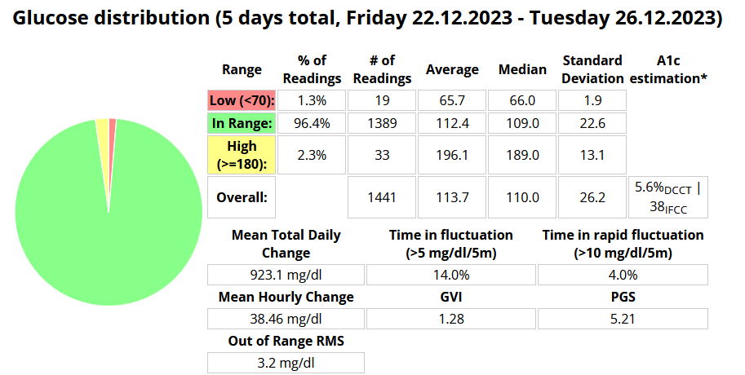
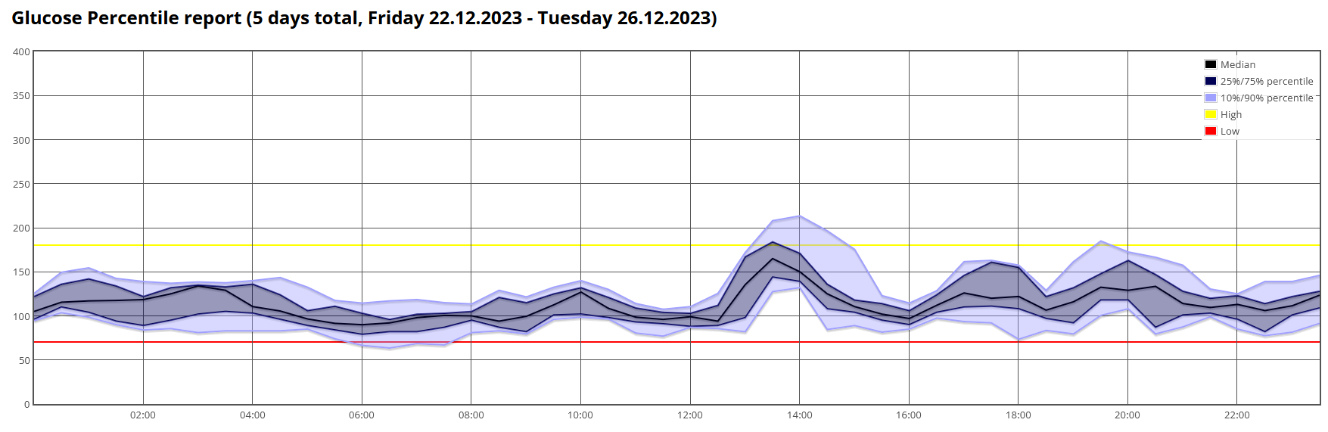
A completely hands-off FCL worked very well on these days that, due to some excessive eating, came with TDD of on average 42.8 U (+16% to normal TDD averaging 37U). No big breakfasts, but two very big holiday lunches, and late dinners followed once (Dec24/25 ) by a midnight chocolate fondue w/ 2 gl. sweet hot wine (Glühwein) were included, all without manually adjusting any settings.
Using the new activity monitor seemed sufficient to deal with automatic adjustments to frequent inactivity, as well as to several 30-45 minute daily dogwalks.
(If more “serious” exercise would have been included, I would have used some form of “exercise announcement”, and/or would have required snacks to avert hypos).
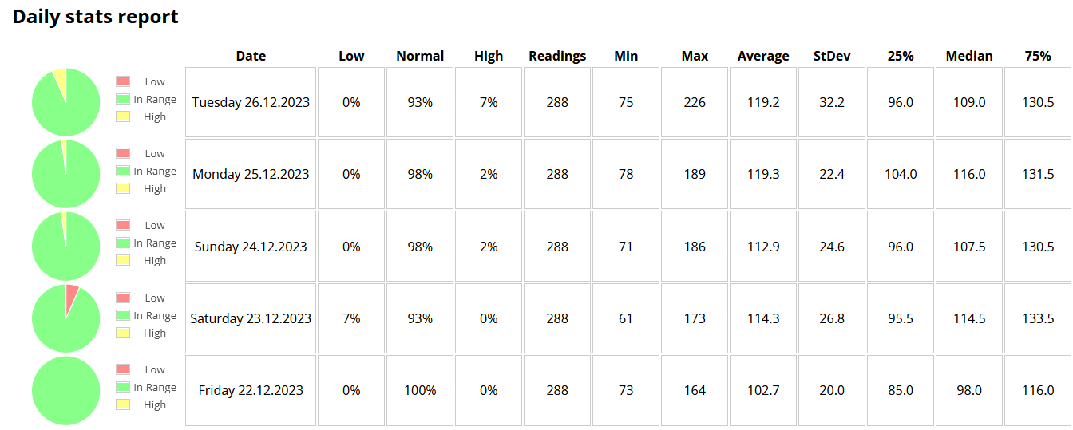
In the daily charts that follow, the SMB sizes are indicated (no bolus was ever given).
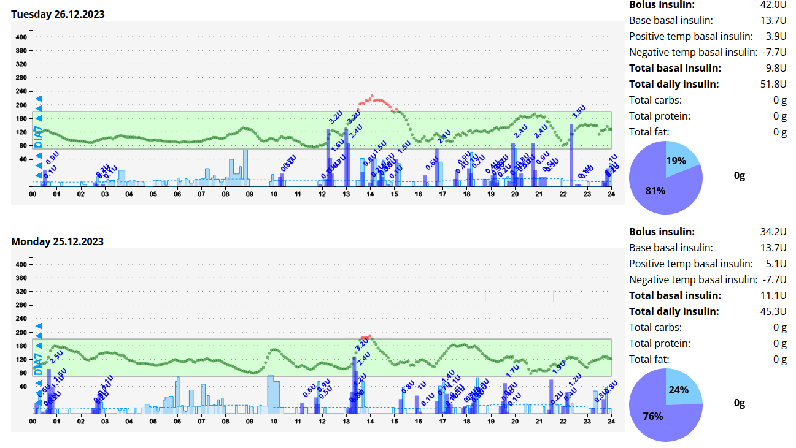
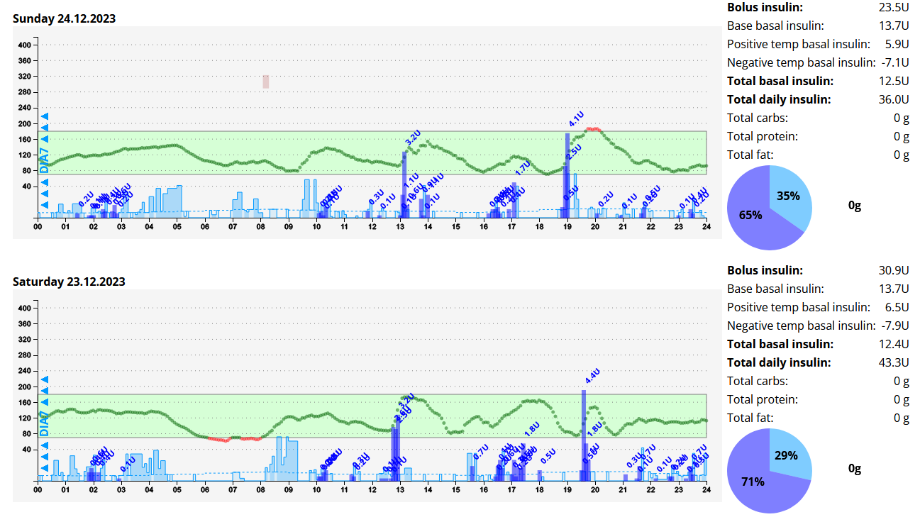

Conclusion

On days without heavy exercise it seems possible to let the FCL run without any user interference, once the initial settings are dialed in.
Going ~ 20% higher in carb intake is no problem for the sophisticated way autoISF auto-adapts to the predicted further glucose curves.
Users should resist the temptations to “nudge”, be it with temporary settings or even by sometimes giving a bolus. Any such user action disturbs the workings of the autoISF loop and is – at least on average –unlikely to lead to a better result.
What the user still should do is:
- Look occasionally after BT connectivity (especially after meal starts)
- Look occasionally into the bg and iob (or insulin activity, thin yellow curve) development, and develop some “mindfulness” so to some extent, and only sometimes, this might influence the eating/snacking habit a bit.
- With very special “disturbances” the hands-off FCL runs into limitations. Notably if the need for extra snacks shall be kept low, ahead of exercise it can be essential to take special precautions for limiting iob and to elevate the glucose target (as known from hybrid closed loop). See example in case study 6.2

